classDiagram
class User {
-String id
-String username
-String email
-String password
-String resetToken
-Date resetTokenExpiry
+register(username, email, password)
+login(email, password)
+requestResetPassword(email)
+resetPassword(token, newPassword)
}

class AuthController {
+register(req, res)
+login(req, res)
+forgotPassword(req, res)
+resetPassword(req, res)
}

AuthController --> User : uses

This diagram shows the two main classes in your authentication system:
- User Class:
  - Represents a user in your system
  - Contains properties (fields) like:
    - id: Unique identifier for the user
    - username: User's chosen name
    - email: User's email address (used for login)
    - password: Stored as a hashed value
    - resetToken: Token used for password reset
    - resetTokenExpiry: When the reset token expires
  - Contains methods (functions) to:
    - register: Create a new user account
    - login: Authenticate a user
    - requestResetPassword: Start the password reset process
    - resetPassword: Complete the password reset process
- AuthController Class:
    - Handles HTTP requests for authentication
    - Contains methods that correspond to API endpoints:
      - register: Process registration requests
      - login: Process login requests
      - forgotPassword: Process password reset requests
      - resetPassword: Process setting a new password
    - Uses the User class to perform these operations (shown by the arrow)
This diagram helps you understand how your authentication system is structured in terms of classes and their relationships.

Explanation:
- This diagram shows what actions a user can perform in your authentication system:
  - User: The person using your application (shown as a circle)
  - Register Account: The process where a new user creates an account
  - Login to Account: The process where an existing user authenticates
  - Request Password Reset: The process where a user asks to reset their forgotten password
  - Reset Password: The process where a user sets a new password after receiving a reset link
  - Access Task Manager: Shows that after logging in, users can access the task management features
The arrows show the flow between the user and these actions. This diagram helps you understand what functionality your authentication system needs to provide to users.
Explanation:
- This diagram shows what actions a user can perform in your authentication system:
  - User: The person using your application (shown as a circle)
  - Register Account: The process where a new user creates an account
  - Login to Account: The process where an existing user authenticates
  - Request Password Reset: The process where a user asks to reset their forgotten password
  - Reset Password: The process where a user sets a new password after receiving a reset link
  - Access Task Manager: Shows that after logging in, users can access the task management features
The arrows show the flow between the user and these actions. This diagram helps you understand what functionality your authentication system needs to provide to users.
Explanation:
- This diagram shows what actions a user can perform in your authentication system:
  - User: The person using your application (shown as a circle)
  - Register Account: The process where a new user creates an account
  - Login to Account: The process where an existing user authenticates
  - Request Password Reset: The process where a user asks to reset their forgotten password
  - Reset Password: The process where a user sets a new password after receiving a reset link
  - Access Task Manager: Shows that after logging in, users can access the task management features
The arrows show the flow between the user and these actions. This diagram helps you understand what functionality your authentication system needs to provide to users.

Explanation:
- This diagram shows what actions a user can perform in your authentication system:
  - User: The person using your application (shown as a circle)
  - Register Account: The process where a new user creates an account
  - Login to Account: The process where an existing user authenticates
  - Request Password Reset: The process where a user asks to reset their forgotten password
  - Reset Password: The process where a user sets a new password after receiving a reset link
  - Access Task Manager: Shows that after logging in, users can access the task management features
The arrows show the flow between the user and these actions. This diagram helps you understand what functionality your authentication system needs to provide to users.

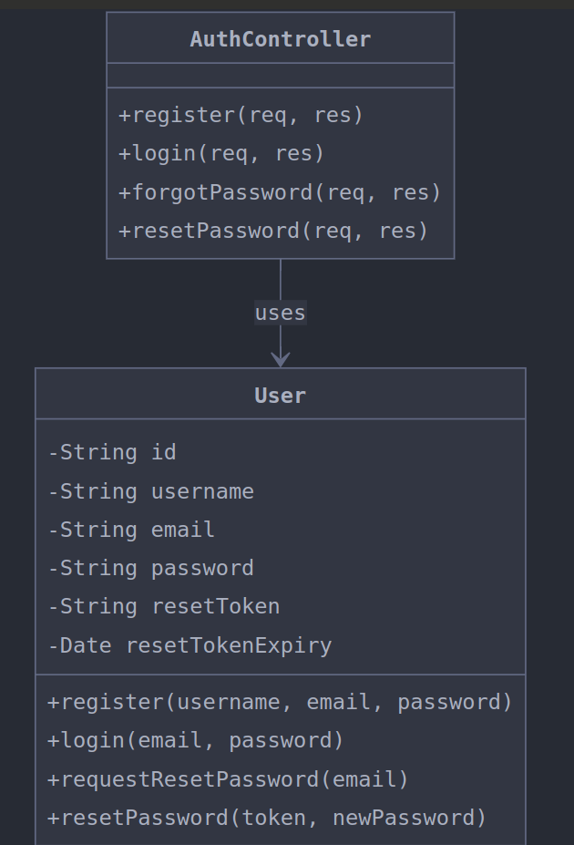

2. Simplified Use Case Diagram
Explanation:
- This diagram shows what actions a user can perform in your authentication system:
  - User: The person using your application (shown as a circle)
  - Register Account: The process where a new user creates an account
  - Login to Account: The process where an existing user authenticates
  - Request Password Reset: The process where a user asks to reset their forgotten password
  - Reset Password: The process where a user sets a new password after receiving a reset link
  - Access Task Manager: Shows that after logging in, users can access the task management features
The arrows show the flow between the user and these actions. This diagram helps you understand what functionality your authentication system needs to provide to users.

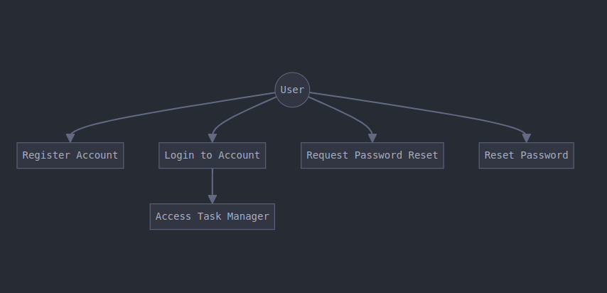
3. Login Sequence Diagram (from the earlier, more detailed set)

Explanation:
- This diagram shows the step-by-step process of a user logging in:
  - User enters credentials: The user types their email and password in the login form
  - Client sends login request: The front-end sends these credentials to the API
  - API checks database: The server looks up the user by email
  - Database returns user data: If found, the database returns the user information
  - The diagram then shows two main paths:
    - If user is found:
      - The API verifies the password
      - If correct: Generates a JWT token and returns it along with user info
      - If incorrect: Returns an authentication failure message
    - If user is not found:
      - Returns an authentication failure message
This diagram helps you understand the exact sequence of events that happens during login, including success and failure scenarios.

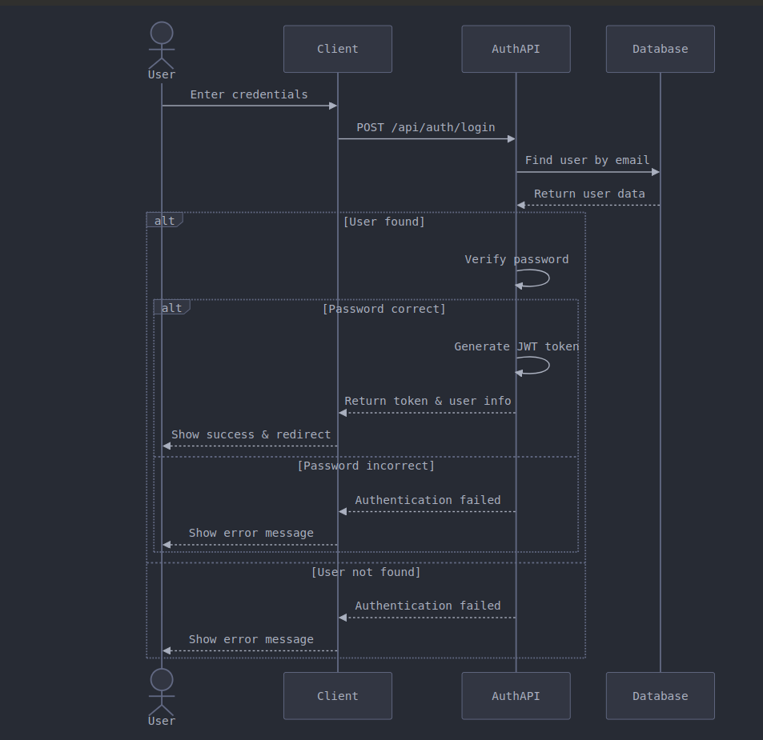

4. Registration Sequence Diagram (from the earlier, more detailed set)
Explanation:
- This diagram shows the step-by-step process of a user registering for a new account:
  - User enters registration details: The user provides username, email, and password
  - Client validates input: The front-end checks that all fields are valid
  - Client sends registration request: The front-end sends the data to the API
  - API checks for existing email: The server checks if the email is already in use
  - The diagram then shows two paths:
    - If email is not in use:
      - The API hashes the password
      - Creates a new user in the database
      - Returns a success message
      - Client redirects to login page
    - If email is already in use:
      - Returns an error message
      - Client shows the error to the user
This diagram helps you understand the registration flow, including the validation and error handling.

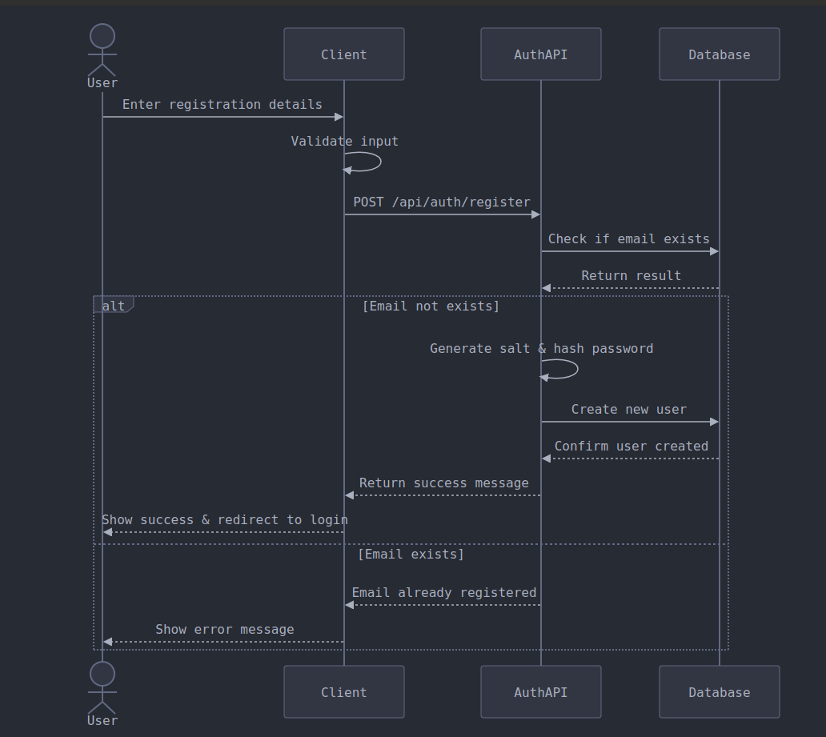

5. Password Reset Sequence Diagram (from the earlier, more detailed set)

Explanation:
- This diagram shows the complete password reset process in two parts: Part 1: Requesting the Reset
  - User requests password reset: The user enters their email address
  - Client sends reset request: The front-end sends the email to the API
  - API looks up the user: The server checks if the email exists
  - If the user is found:
    - The API generates a unique reset token
    - Saves the token with an expiry time
    - Sends an email with a reset link
    - Notifies the user to check their email
  - If the user is not found:
    - Returns an error that the email was not found
Part 2: Setting the New Password
  - User clicks the reset link and enters a new password
  - Client sends the token and new password: The front-end sends this to the API
  - API verifies the token: The server checks if the token is valid and not expired
  - If the token is valid:
    - The API hashes the new password
    - Updates the user's password
    - Returns a success message
    - Client redirects to login page
  - If the token is invalid or expired:
    - Returns an error message
    - Client shows the error to the user
This diagram helps you understand the complete flow of the password reset process, including both the request and the actual reset steps.
